**Terraform Task – 1 Date : 02-09-2024**

**1) Install Terraform on your PC**

* Download terraform from the official site we can get a zip file extract the file to a folder in c drive
* Then add the path of the folder in environmental variables

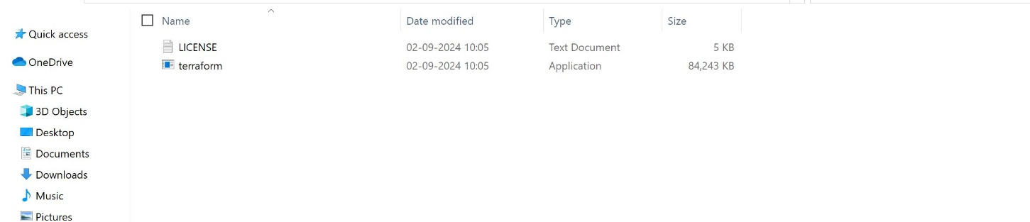

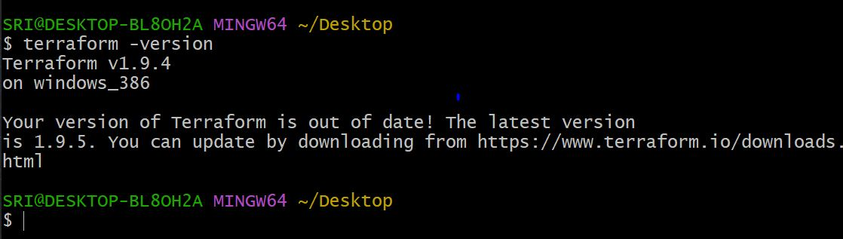

**2) Execute all the templates shown in video.**

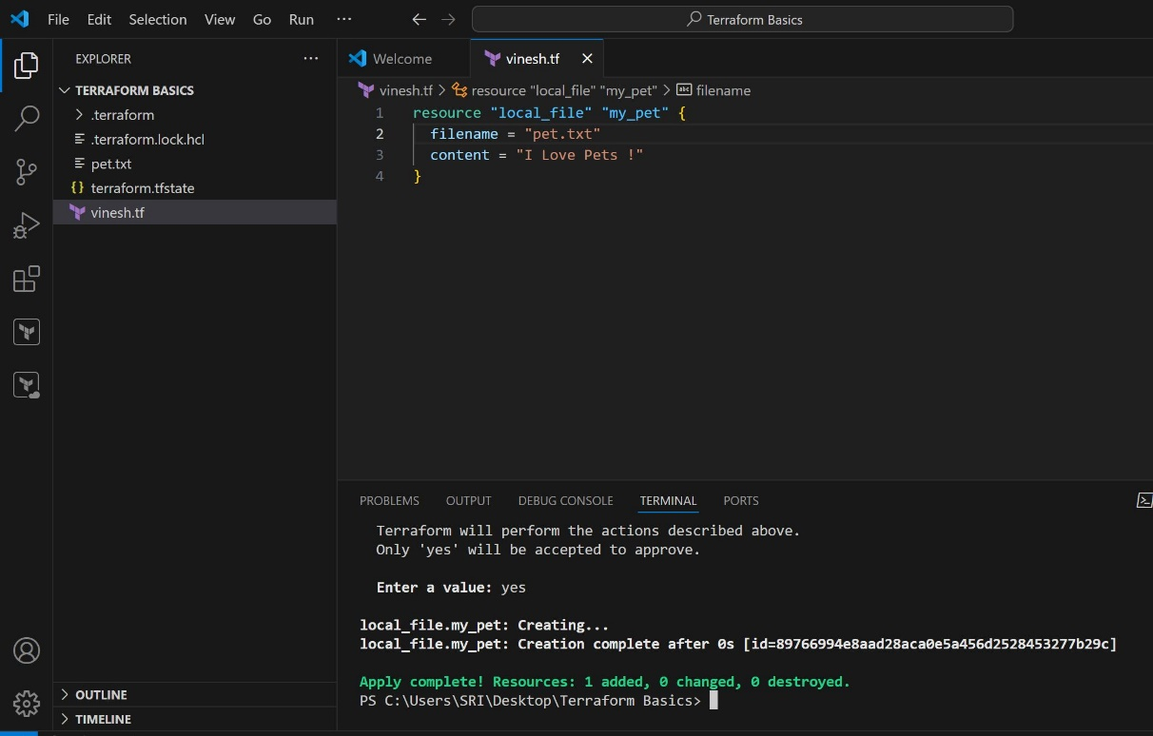

**4) Integrate a sample Terraform template in jenkins.**

